Name: Siddhi Lokhande PRN: 2019BTECS00014

Batch: T3

TY CSE – II (2021-22)

Assignment No – 1

Topic - Introduction to OSS

* 1. Weka is a GUI workbench that empowers data wranglers to assemble machine learning pipelines, train models, and run predictions without having to write code. Using Weka tool perform below tasks such as data pre-processing, data classification (use any appropriate ML algorithm) and data visualization efficiently on given dataset.

Data Pre-processing:

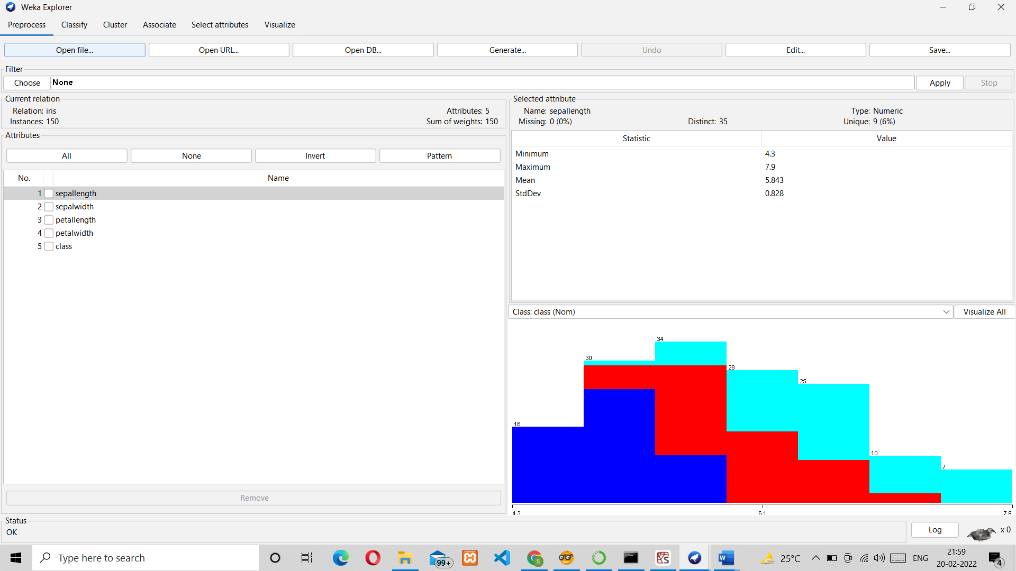

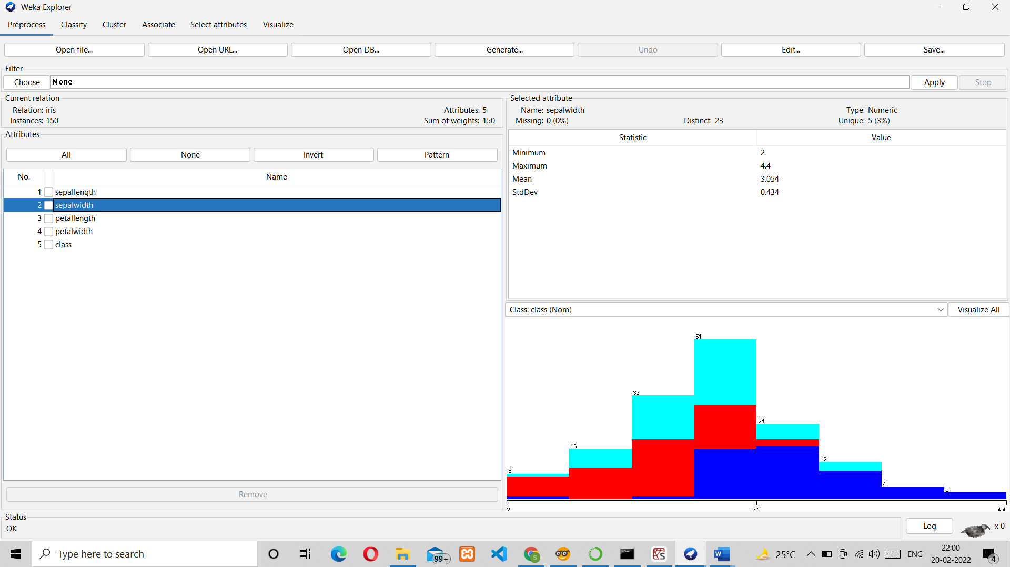

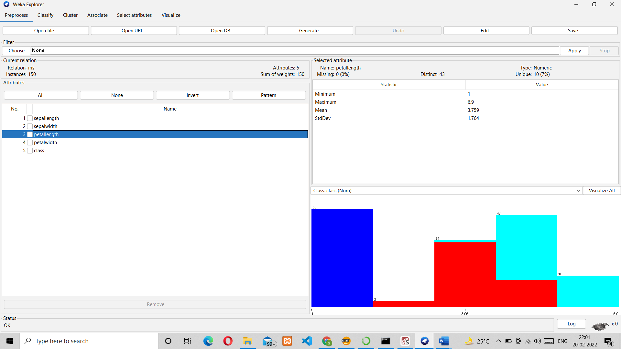

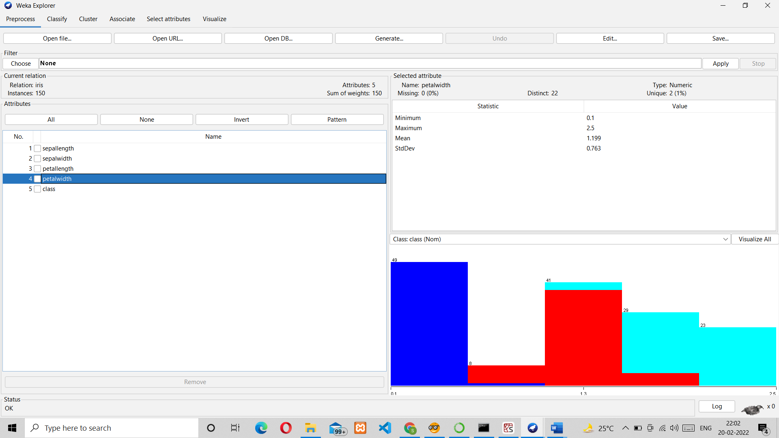

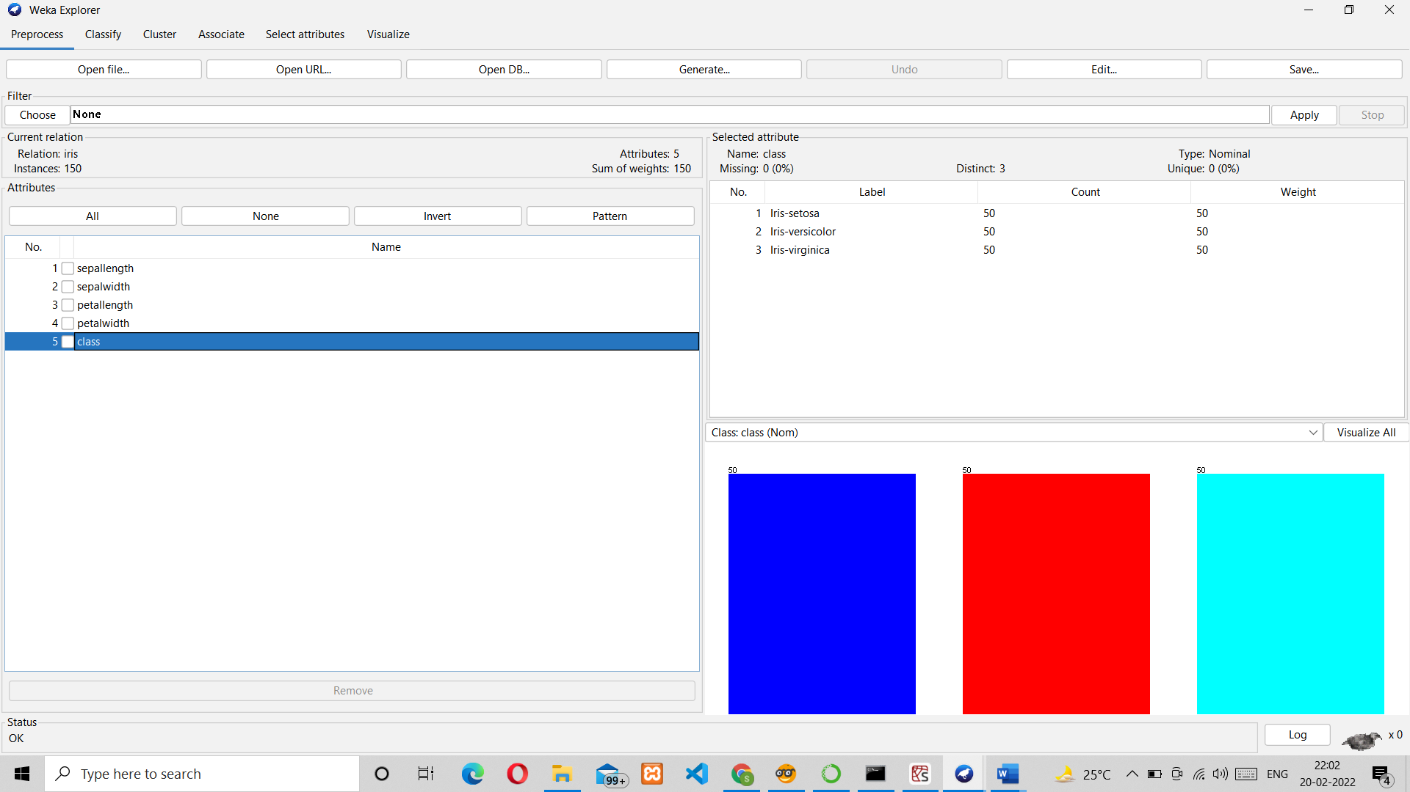

Data Classification:

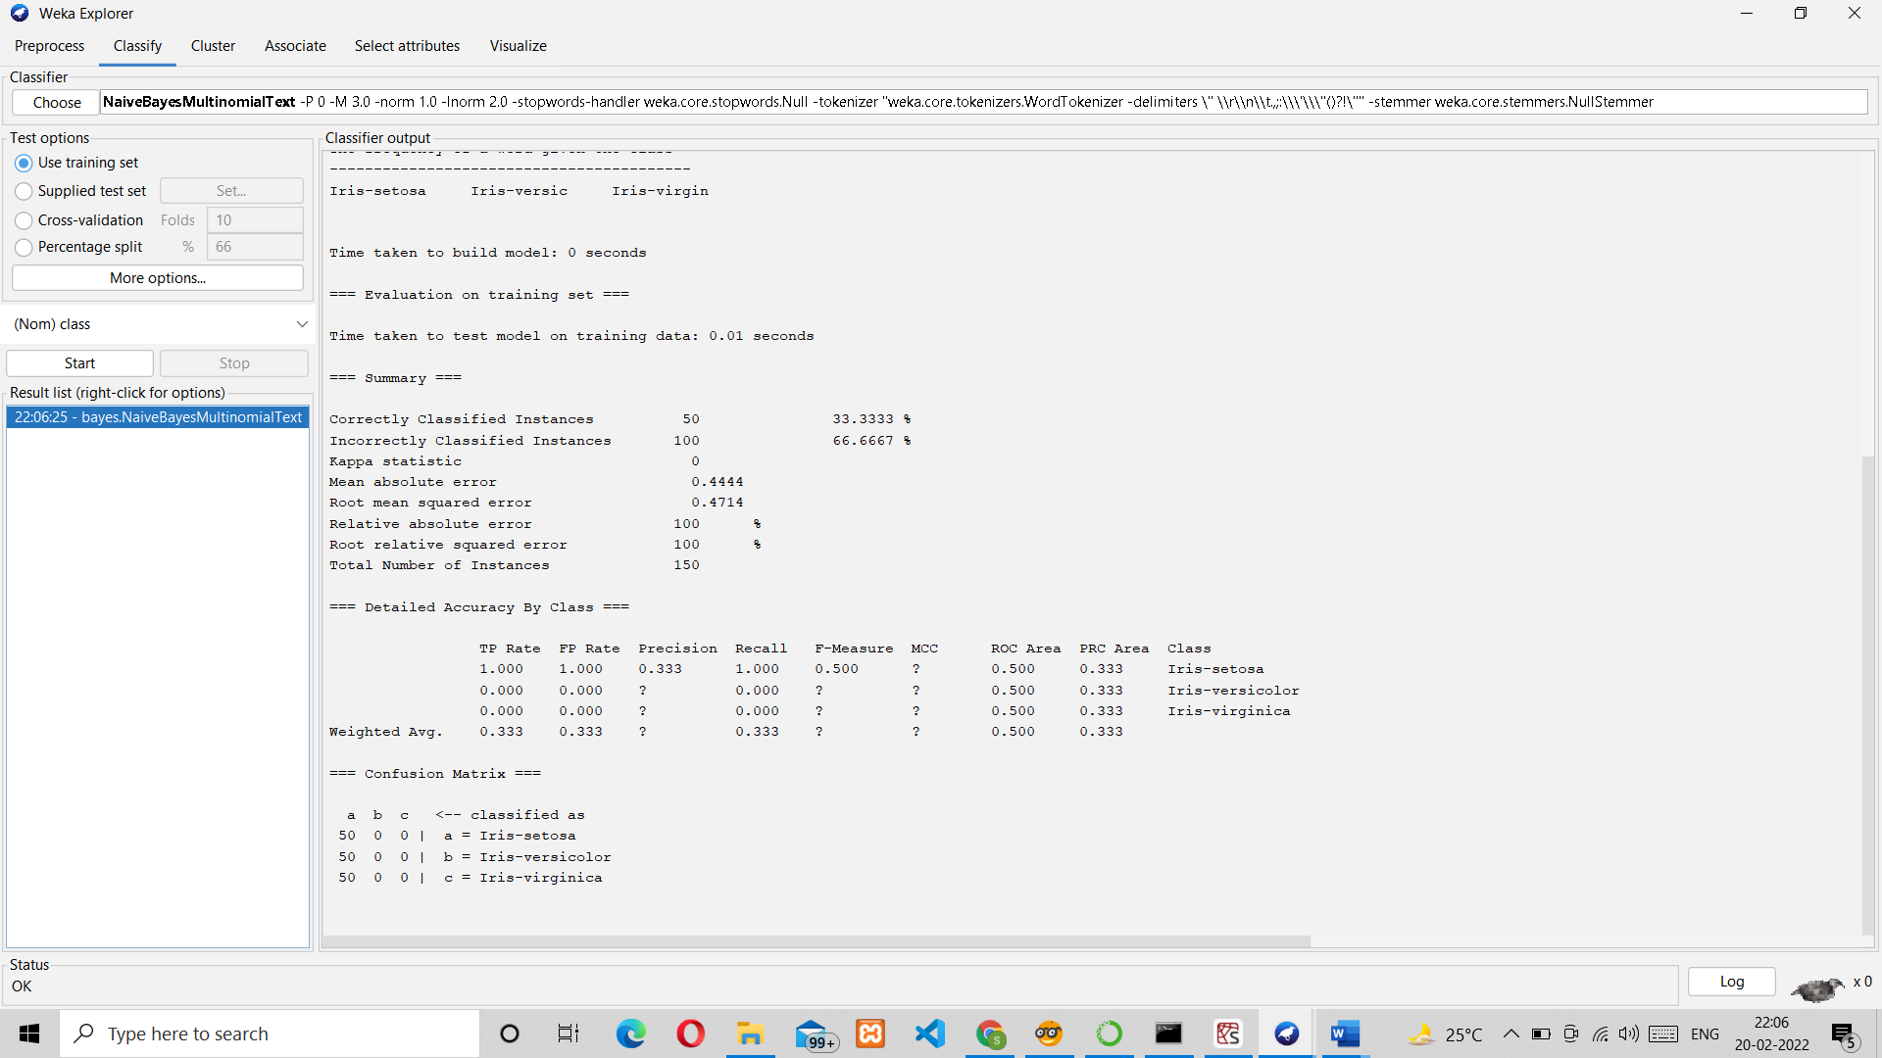

Data visualization:

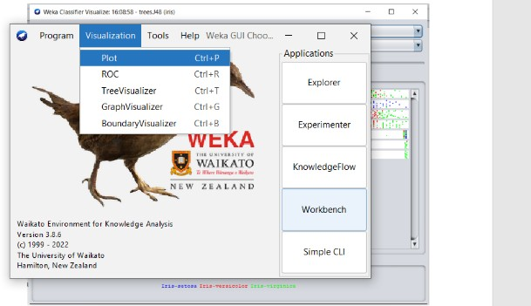

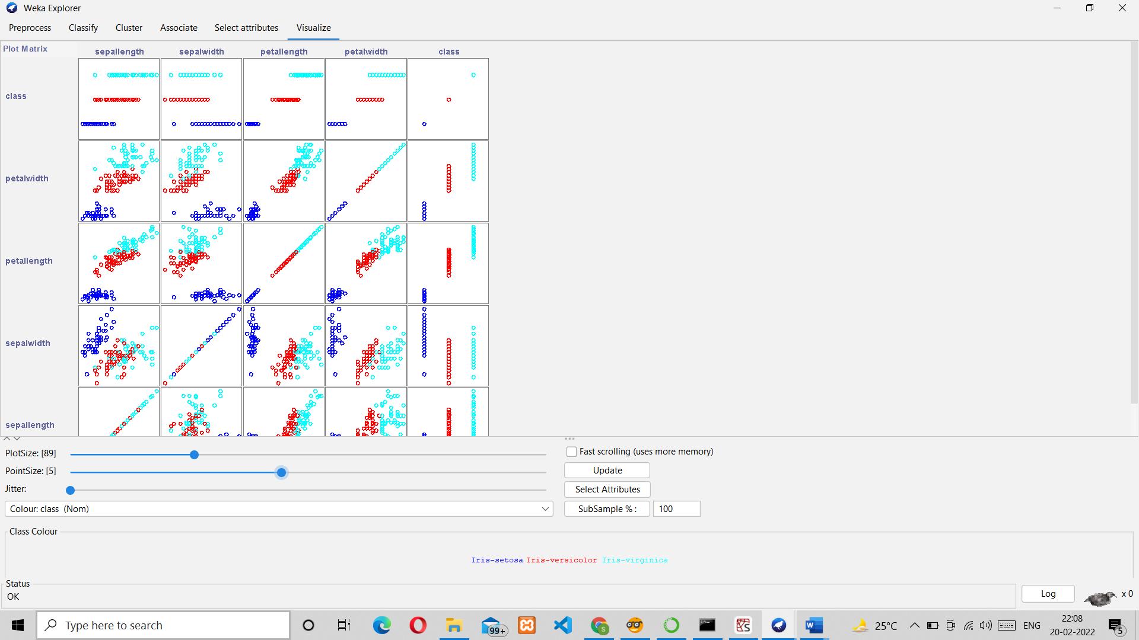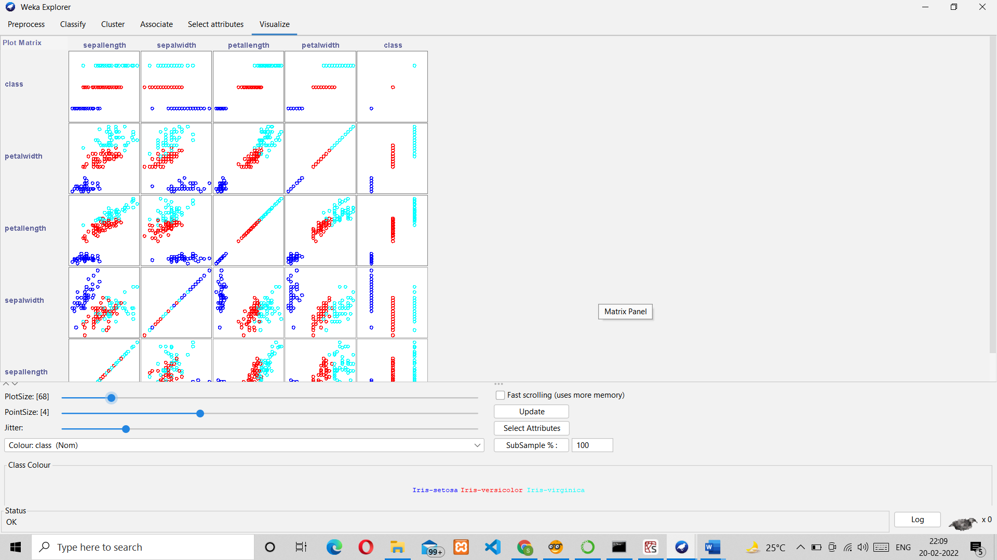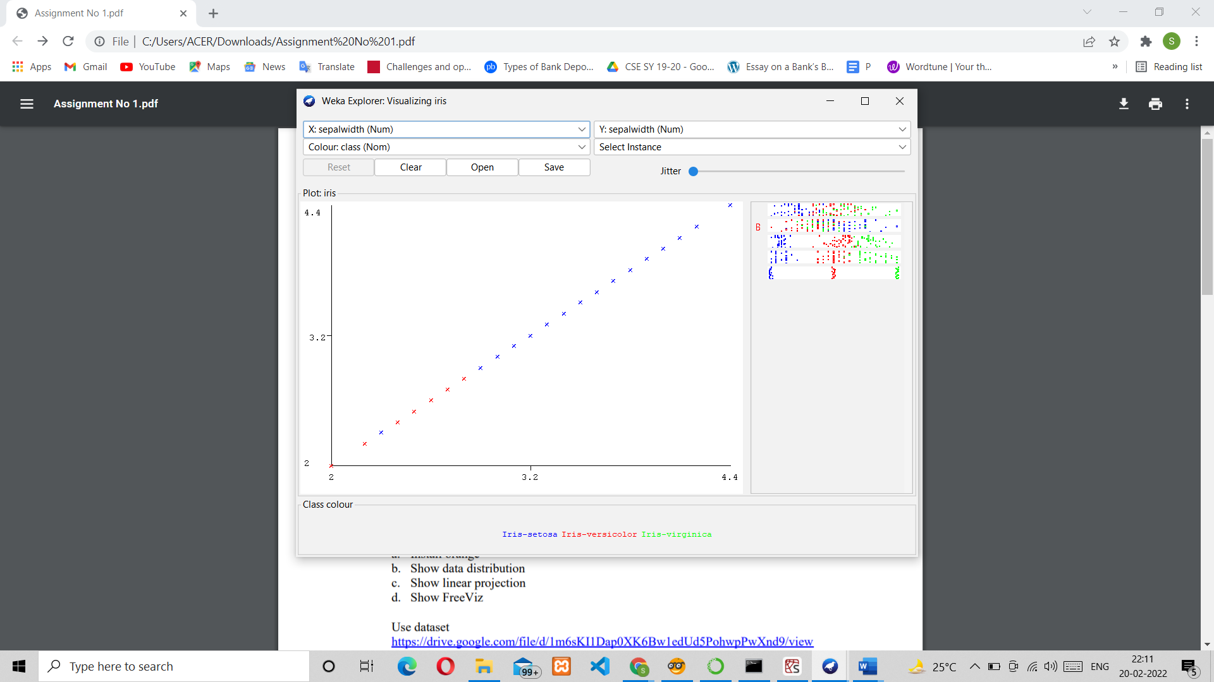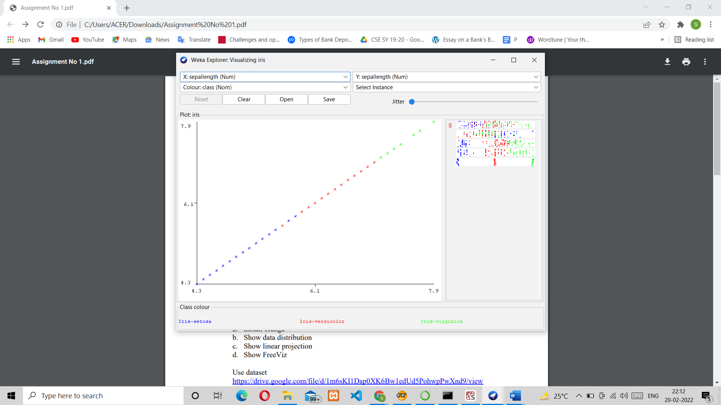

* 1. Orange is an easy to use data visualization tool with a large toolkit. In spite of being a GUI-based beginner-friendly tool, you mustn’t mistake it for a light-weight one. It can do statistical distributions and box plots as well as decision trees, hierarchical clustering and linear projections.

Install orange:

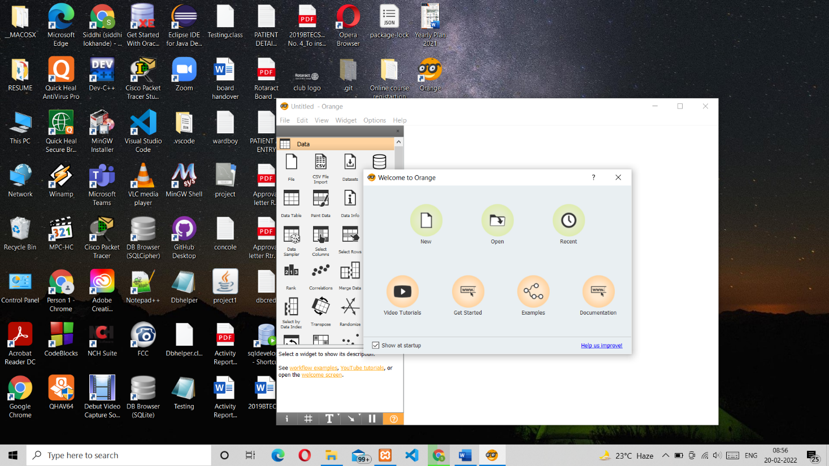

Data distribution:

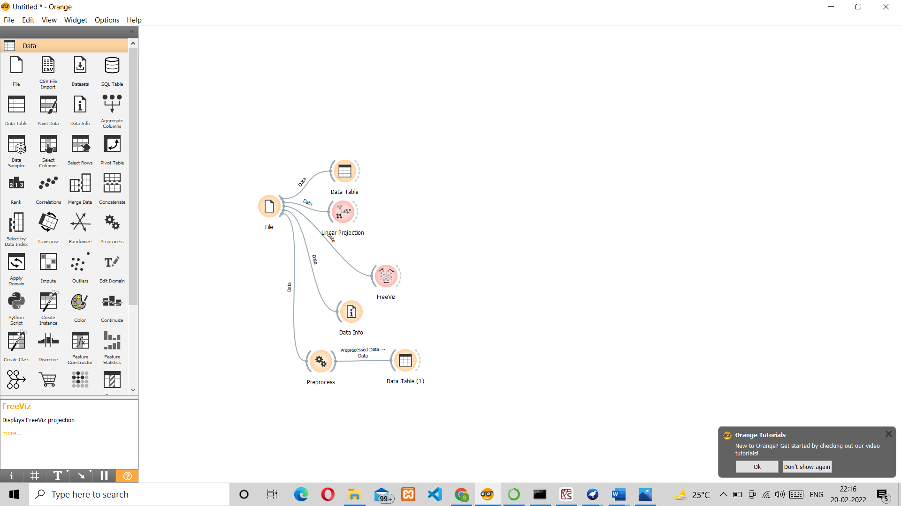

Linear distribution:

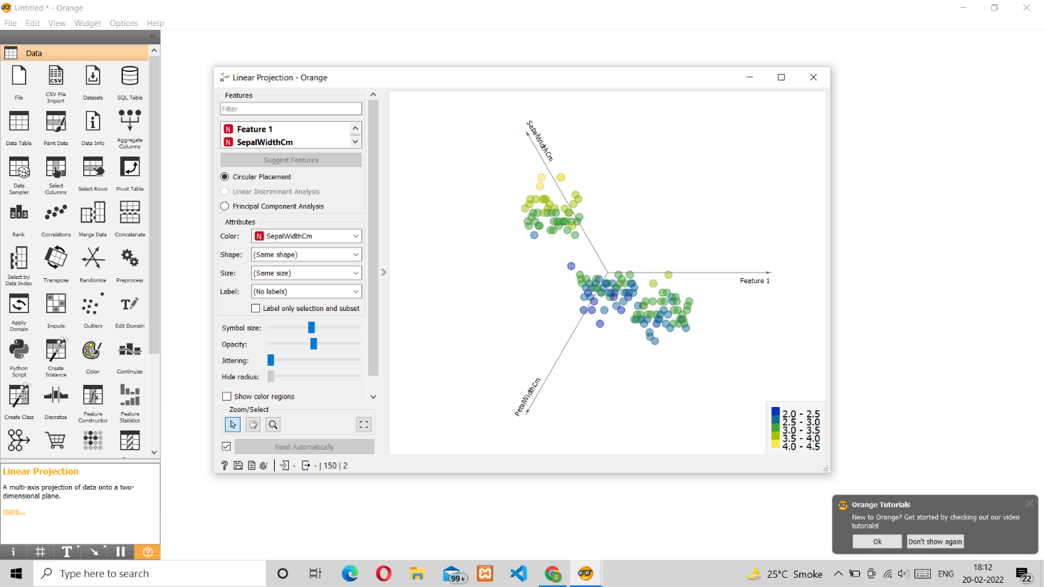

FreeViz:

* + 1. Circular:

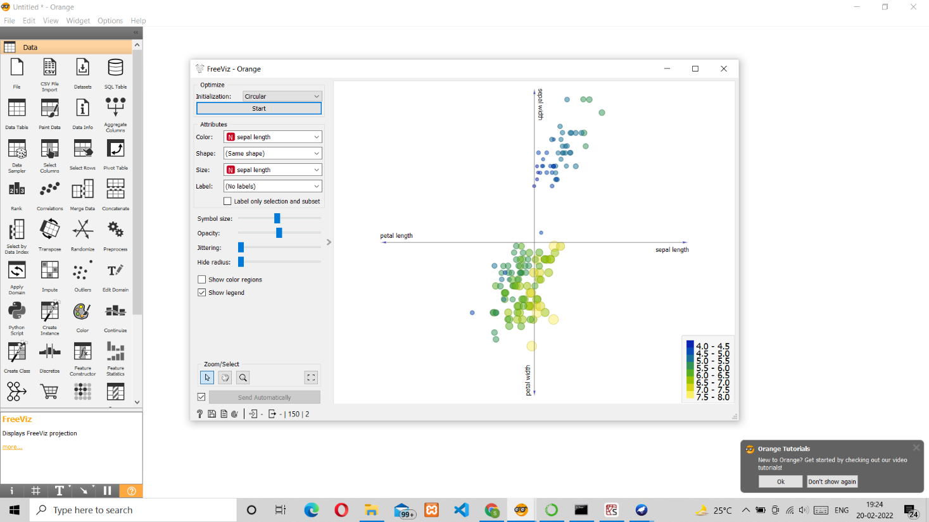

* + 1. Random:

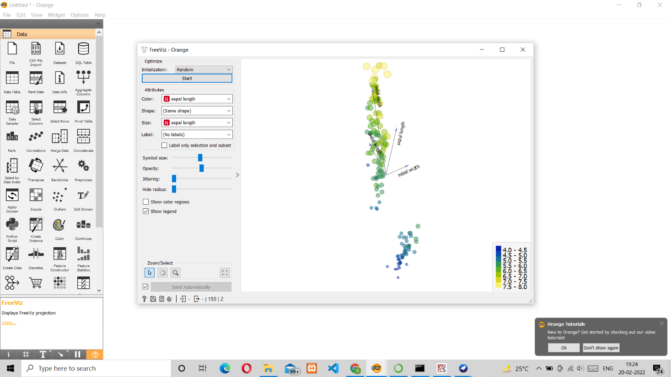

* 1. Differentiate in between free software, Open source software and proprietary software with respect to its properties.
     + Open Source software is the software that is open to use for all. But Proprietary software is the software that is copyrighted.
     + While Open Source software is developed for open collaboration, Proprietary software is not meant for collaboration, but only for the creators and its users who paid for it.
     + Open Source software has an open access. But Proprietary software has a limited and restricted access.
     + Open Source software is flexible, that is, anyone can use, modify and distribute it. But Proprietary software has limited flexibility. Its creators own the right to its source code and only those who have paid and bought it can further use it.
     + Open Source software is not meant for those who do not have any basic knowledge about programming. Whereas Proprietary software can be used by anyone irrespective of their skill level.
     + While the examples of Open Source software are FreeBSD, Android, LibreOffice, Ubuntu and Firefox, the examples of Proprietary software are Windows, Microsoft, Adobe Flash Player and Photoshop an iTunes.
  2. Using Anaconda Python create Histogram, Scatter plot and Bar plot for the dataset given below.

1. **Scatter plot- Scatter plot of Price Vs Age**

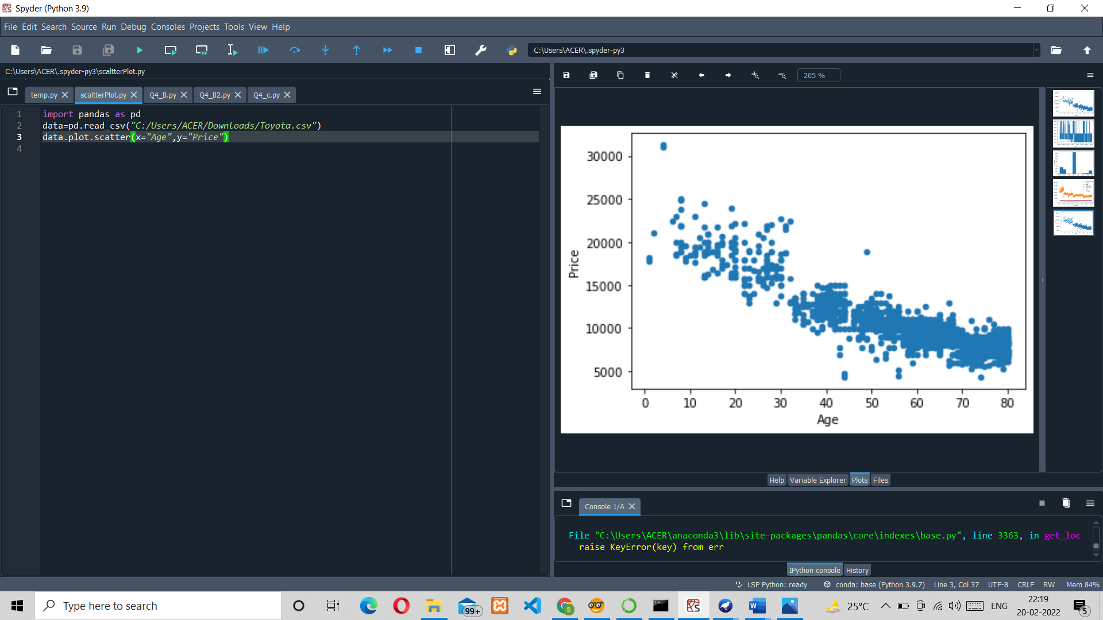

1. **Histogram for Kilometre and CC**

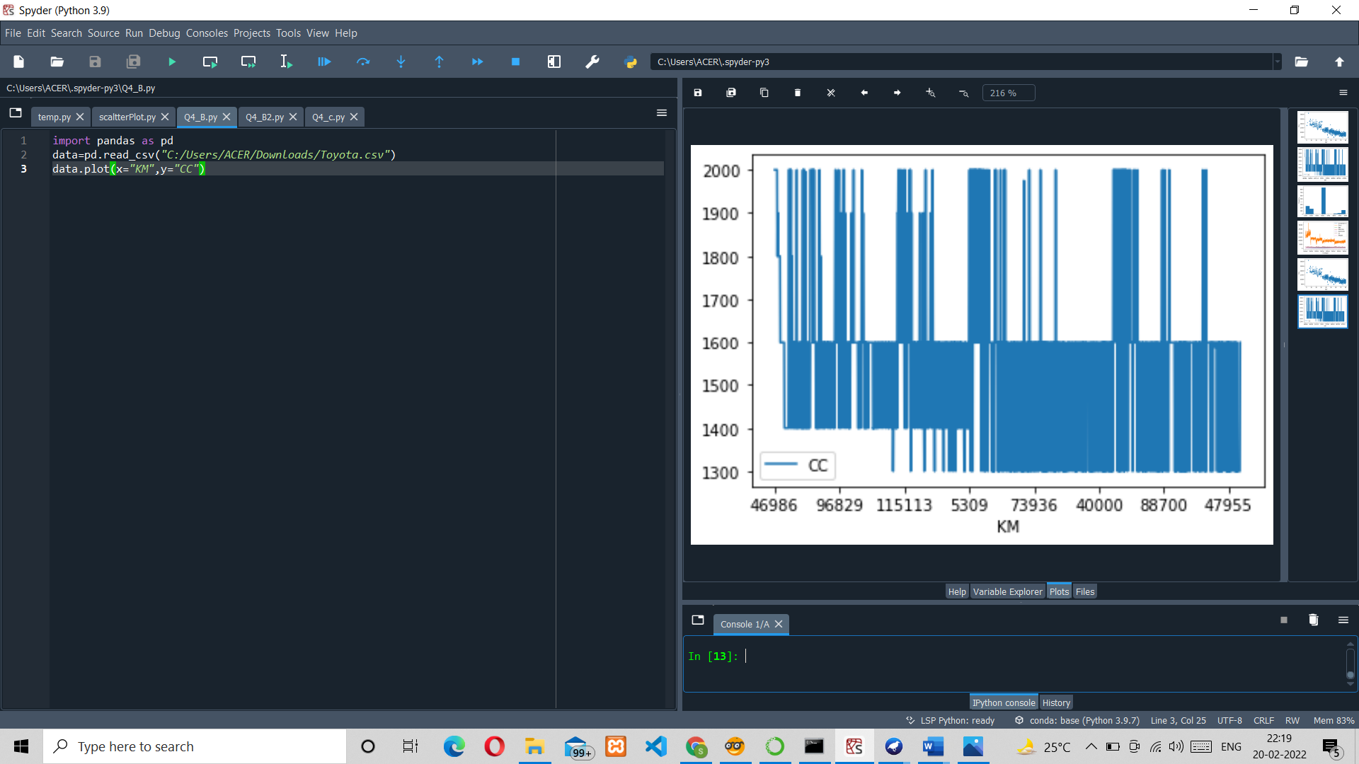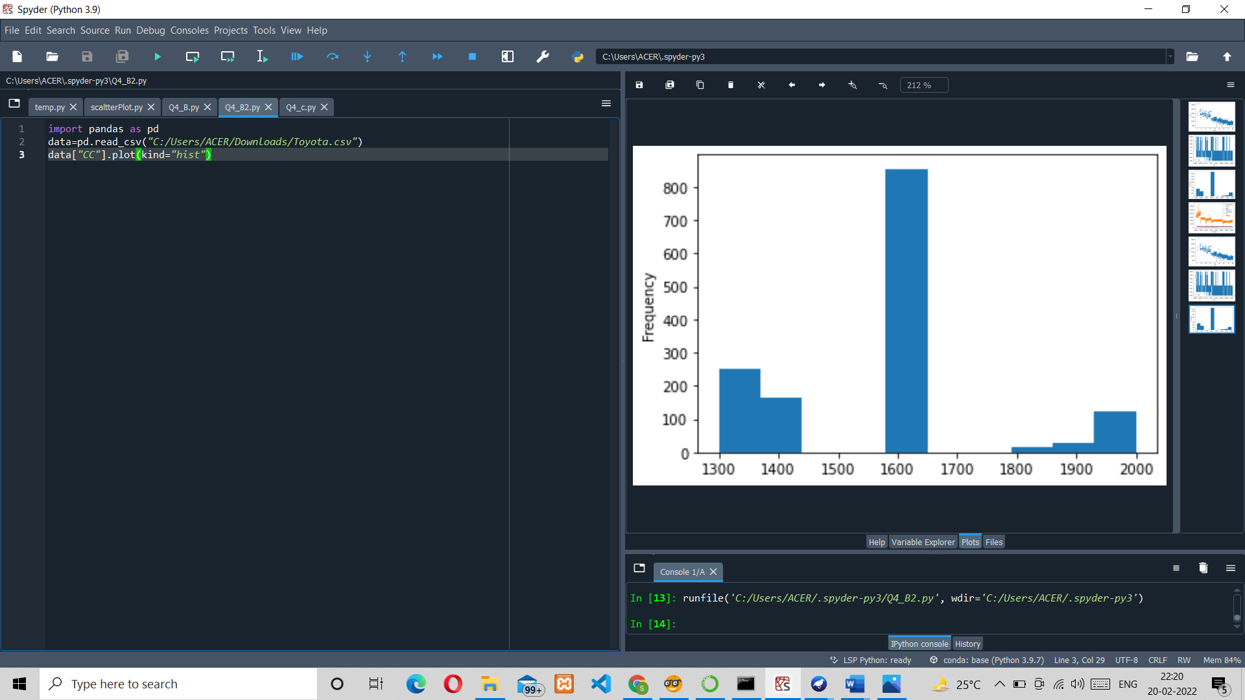

1. **Bar plot- Bar plot for different fuel types**

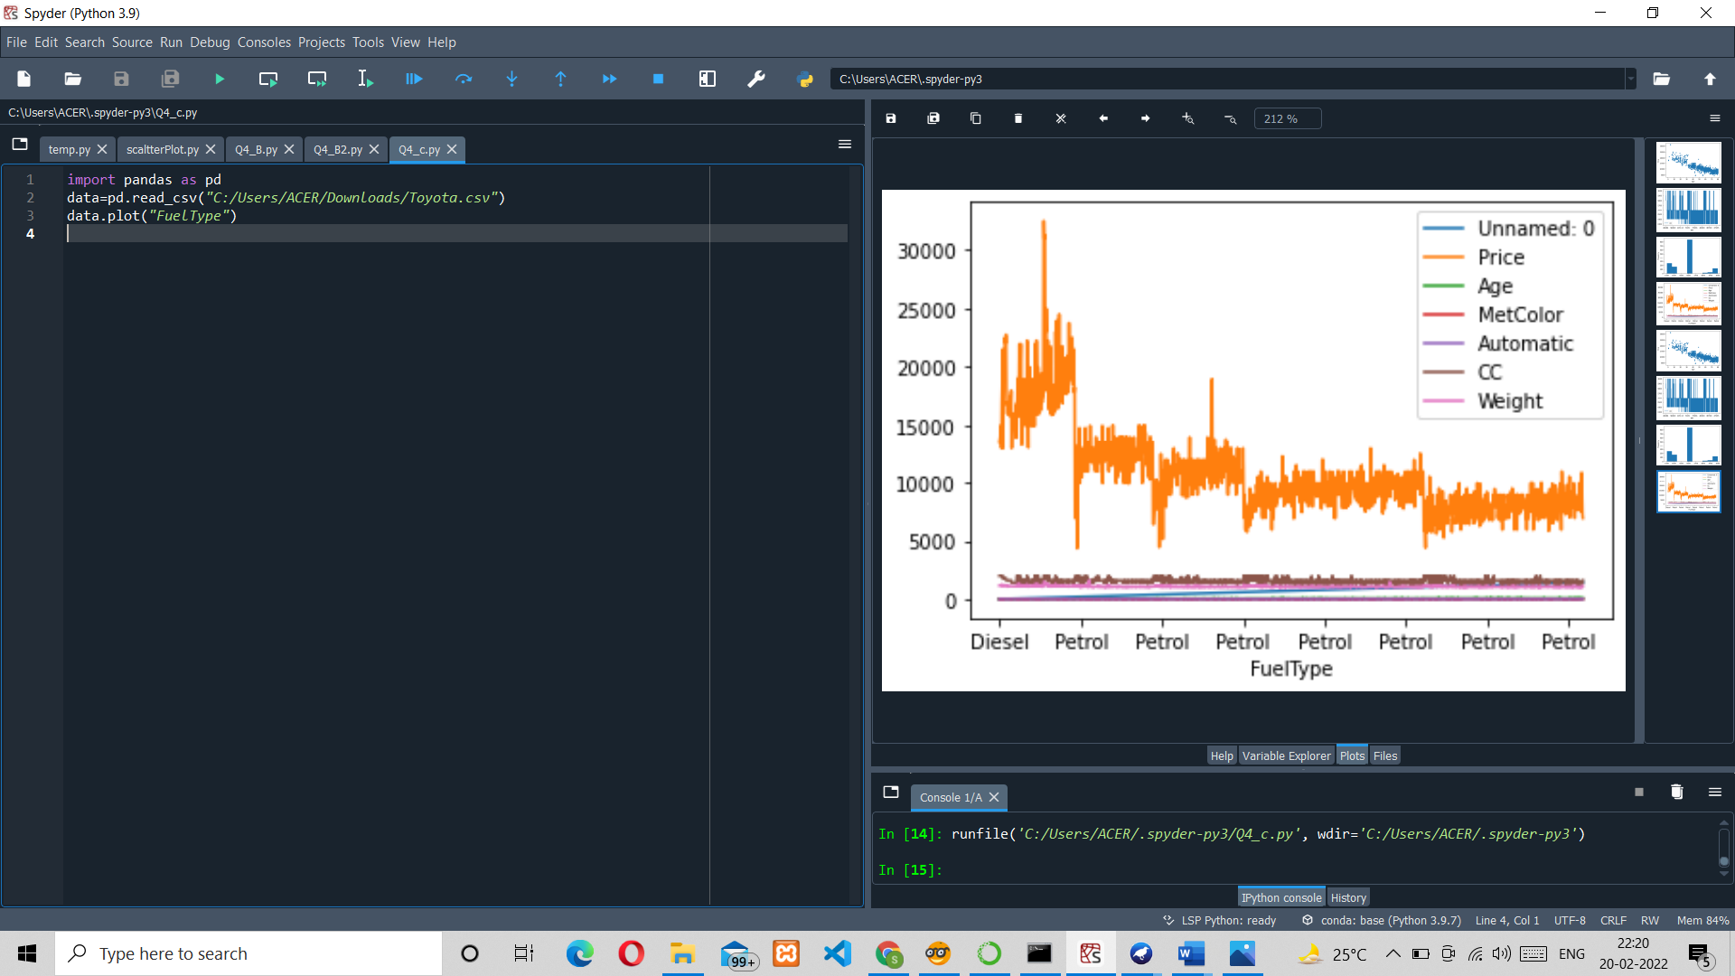

* 1. Enlist some examples along with its purpose and properties (at least 10) of FOSS and proprietary software with respect to database.

FOSS (Free-open-source-software):

Free and open-source software (FOSS) is a software that can be classified as both free software and open-source software.

Examples: Ubuntu, VLC Player, Android system, etc.

# Advantages of FOSS:

1. Expansive licensing: Proprietary software licenses are usually quite restrictive in terms of use, number of users, type of machine and other. There is fee to own license of a proprietary software. Open-source software are free to own there is no restriction on how we use the software, we can install it on unlimited machines.
2. Transparency: Open-source development is carried out openly. As software code is openly available anyone who finds some bug can fix it for others. As development process is carried out publicly its development process is transparent. Users can easily communicate with product developers to understand their product decisions and offer opinions for betterment of software.
3. Source Code inspection: As source code is openly available anyone can view code of the software for better understanding of how the application works.
4. Source Code modification: We can also modify code after inspecting the code. One can modify code and for himself and also, he can add those changes to main version of software so that changes will be available for everyone for use.
5. Community: Foundation of open source projects is community, it includes developers of software and also users. Users in community can easily share there feedback with developers so that developers can improve the software.
6. Redistribution rights: Open-source licenses allow users to perform some changes in software and again redistribute the software without taking permission of the original product owner.

### Proprietary Software:

This type of software requires licenses for their use. Company or organization that owns the software provides rights to use the software to customer. Users can only install software only on limited number of machines and cannot redistribute it.

1. Increased Functionality and Convenience

Proprietary systems are easier to use and learn, leading to faster work processes. Skype, for example, is used by organizations worldwide. It takes minutes to sign up for an account and make international phone calls or conduct video interviews online. On top of that, your customers, suppliers and employees may already have a Skype account, so they know how to use it.

Open-source programs are trickier to use and may lack user-friendly features, affecting productivity in the workplace. Unskilled end users may find it difficult to navigate them and take full advantage of what they have to offer. After all, there is a reason so few people use Linux.

## Superior Customer Support

Open-source software can be difficult to install and set up. Customizing it isn't easier either. Plus, your staff may not be familiar with the program and may need additional training.

The average employee lacks the expertise to use open-source programs. Therefore, your team members may need help with most tasks. They will spend hours trying to figure things out instead of focusing on the tasks at hand.

Proprietary software is more accessible and includes technical support. Most companies offering these programs provide dedicated sources, 24/7 assistance, live chat and user manuals. The antivirus program Bitdefender, for example, offers online resources, technical support around the clock and security-configuration services for enterprises. If your employees experience any issues, they can simply call or email the service provider.

## Lower Maintenance Costs

As a small-business owner, you may prefer open-source software due to its low cost. Most programs are free or cost next to nothing. The downside is that you may end up paying a lot more for setup, maintenance and customization than you'd pay with proprietary software.

Some open-source programs are difficult to install and set up, so you may need to call an expert to do the job. In some cases, new hardware may be necessary to use the software. If your employees are not familiar with the program, they will need support and training, which may further increase the costs. Updating the software, testing new versions and applying patches isn't cheap either.

## Stronger Competitive Advantage

Proprietary technology enables organizations to be more profitable, productive and innovative. This is particularly true for software-development companies, which often use custom programs at the core of their business model.

Even if you're not a software developer, you can still benefit from using proprietary systems. For example, you may hire a team to create software programs that integrate with your existing technology. This may improve work performance and productivity in your organization, streamline business processes and increase production. Furthermore, you may customize the program and add new features as your business changes.

## Secure Financing for Your Business

Nearly one-third of startups close their doors because they run out of capital. Developing proprietary technology doesn't guarantee success, but it could make it asier to secure financing for your small business. Plus, you will be able to charge higher prices because no other company offers the same product as you do.

As it turns out, big data investors prefer to put their money in companies selling proprietary software — or at least something other than open-source software, such as proprietary add-ons. This kind of technology isn't restricted by what already exists in the market.

Examples:

# Atom Editor

Purpose:

Atom is a free and open source code editor and source code editor for macOS, linux and windows with support for plugin written in JavaScript and embedded git control.

**Properties:**

* + - Customizable
    - Atom is a "hackable" text editor
    - One can even make a package to wrap all of this functionality into a single package
    - enables users to install third-party packages
    - Syntactic highlighting support for other languages than the default
    - Easily extensible through extra packages that provide among other things code autocompletion for a wide variety of languages
    - FTP capabilities, and built-in browser preview.

# NextCloud:

### Purpose:

NetCloud simplifies network management by making it easy to understand and apply licenses, identify and push out software updates, upgrade software feature sets, amass education tools, and connect with other customers.

### Properties:

* + [End-to-end encryption](https://nextcloud.com/endtoend)
  + [Virtual Data Rooms](https://nextcloud.com/virtual-data-room)
  + [User management and authentication (LDAP, SAML, 2FA)](https://nextcloud.com/usermanagement)
  + [Online document editing with Collabora Online](https://nextcloud.com/collaboraonline)
  + [Mobile and desktop clients](https://nextcloud.com/clients)
  + [Secure file sharing abilities](https://nextcloud.com/sharing)
  + Scalability
  + [Customer file upload (file drop)](https://nextcloud.com/file-drop)
  + virtual data rooms
  + Monitoring and handling

# Celestia:

### Purpose:

Celestia allows users to navigate at different speeds, and allow users to orbit stars, planets, moons, and other space objects, track space objects such as spacecraft, asteroids, and comets as they fly by, or travel to and/or fly through galaxies.

**Properties**:

* + The user can change Celestia's field of view
  + allows users to split the window into multiple panes
  + Celestia allows users to navigate at different speeds
  + allow users to orbit stars, planets, moons, and other space objects
  + Screenshots and movies can be captured in classic or HD resolutions.
  + track space objects such as spacecraft, asteroids, and comets as they fly by
  + Information about the objects that Celestia draws can also be displayed.
  + The user can change Celestia's field of view

# FreeRDP:

### Purpose:

FreeRDP is a free implementation of the Remote Desktop Protocol (RDP), released under the Apache license. It enables network administrators to remotely diagnose problems that individual users encounter as well as gives users remote access to their physical work desktop computers.

### Properties:

* + smart card authentication
  + bandwidth reduction;
  + the ability to use multiple displays;
  + the ability to disconnect temporarily without logging off;
  + 128-bit encryption for mouse and keyboard data using RC4 encryption;
  + directs audio from a remote desktop to the user's computer;
  + redirects local files to a remote desktop;
  + local printers can be used in remote desktop sessions;
  + applications in the remote desktop session can access local ports;
  + shares clipboard between local and remote computers;

# Blender

### Purpose:

Blender is the free and open source 3D creation suite. It supports the entirety of the 3D pipeline-modelling, rigging, animation, simulation, rendering, compositing and motion tracking, even video editing and game creation

### Properties:

* + 3D modelling
  + UV unwrapping
  + Texturing
  + raster graphics
  + editing
  + rigging and skinning
  + fluid and smoke simulation
  + particle simulation
  + soft body simulation
  + animating